Sesc - Serviço Social do Comércio - and
TAFISA - The Association For International Sports For All - award this certificate of participation

Insert Here the name of your organization

For your participation in Challenge Day 2023, and commitment to contributing and encouraging the development of sports and physical activity in the community.
May 31, 2023

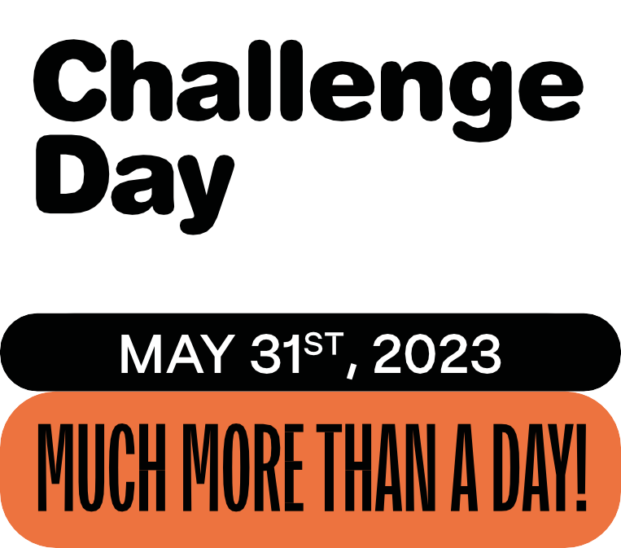

diadodesafio.org.br/en #ChallengeDay

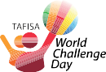
INITIATIVE:

COORDINATION IN THE AMERICAN CONTINENT:

ACCOMPLISHMENT:

CITY HALL

SUPPORT:

